Combustion of Petroleum-Based Fuels
Students Name
Institution Affiliation

ABSTRACT
Smooth engine and automobile combustion is an ideal situation that involves the engine burning fuel to produce mechanical energy to move without causing any form of pollution. This form of pollution has increased rapidly within the last few decades as cars, and automobile manufacturing has multiplied. The purity factor in the fuel is determined by the octane rating and the volatility of the fuel. Purer fuels tend to produce less waste than the less pure fuels, the more the waste gases are produced. Purification of the fuel lads to the production of lesser fuel, making the cost involved to cause a shoot in the cost of fuel. These hydrocarbons are burnt down to produce energy and carbon dioxide in the case of complete combustion, but carbon monoxide in the case of incomplete combustion. The additives in the fuel also accelerate the level of pollution as some of them have a very negative impact on the environment.
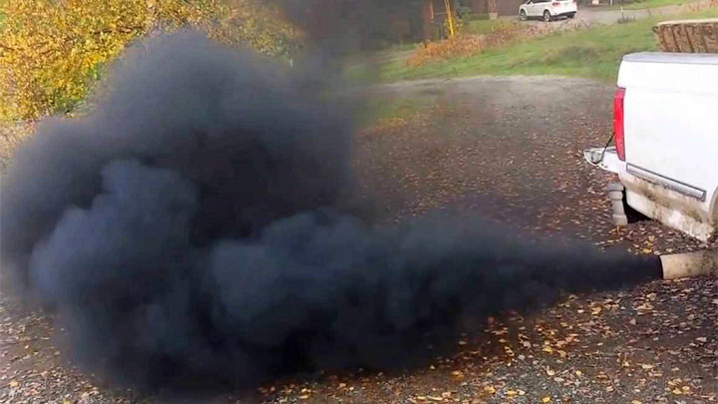

INTRODUCTION
The better engines have better combustion characteristics, but they are costly. Globally the middle-class individuals afford the type of engines that have relatively some relative pollution. In one town the number of operating automobiles are very many everywhere in the world. This makes a collective impact of smoke that is attracted to the atmosphere. The pollutant gases from fuel contain carbon particles and elements of sulfur due to the fuel additives used, such as lead sulfide additives. The gases for a chemical cloud that is in the form of a blanket (Rubin, 2020).it leads to the formation of acid rain and an increase in temperatures as the cloud acts as a blanket.
The octane rating and volatility influence the level of pollution. To control this pollution, the octane rating can be improved through various methods that include; extra refining and use of additives .extra refine of the fuel are a little bit expensive organic chemical process that involves adjustments in the hydrocarbon to get an efficient and less harmful fuel. Reduction of the hydrocarbon chain length, an example is a pentane to methane (110) and butane (94), .adding on
to the double bond character in the hydrocarbon. Branching of the hydrocarbons chains and aromatization of the hydrocarbon.
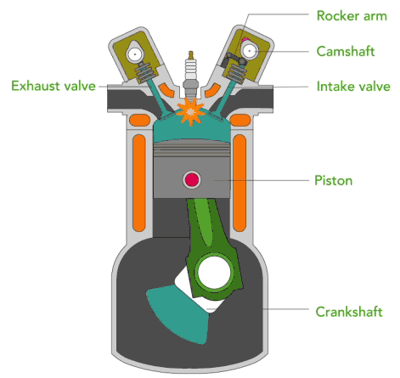
The ratios determine the conversion rate of an engine in the carburetor and the quality of fuel. Some engines convert close to 100%while others have lower energy conversion energy. The current automobile industries have introduced turbo engines when the waste produced from incomplete combustion is recycled to utilize the fuel and reduce environmental pollution through the harmful gases produced by the running engines. Modes of air transport and water vessels are also making a significant contribution to the environment's pollution.
$$HC→ENERGY+CO2$$
METHOD
The amount of possible impact can be determined through a comparison of two countries or regions' statistics. America is known to have a more significant number of modern vehicles, a town without industrial activities can be the best gauge of pollution. The other option is an African country such as Nigeria, a town with no industrial activities was selected. The test was to be carried out on the rainwater in the region. Sampling was done, and at least more than five samples for the test of level ions that are suspected to originate from the combustion of petroleum-based fuel. The carbon dioxide and carbon monoxide and carbon dioxide produced. Results
The concentration of carbon dioxide pollutant in the water
COUNTRY | Sample 1 | Sample 2 | Sample3 | Standard(permissive levels)
Nigeria | 14.0 | 16.2 | 12.8 | 0.8
United States | 1.82 | 2.4 | 1.2 | 0.6

The difference in pollution level between the towns portrays a big difference in the level of pollution.

DISCUSSION
Analysis

The effects of this combustion can lead to health hazards in an individual's life if inhaled for a long time. There are many people who operate on a daily basis in the streets and busy townships for a living. Their health is placed at greater risk. The other effect is the acid rain that accumulates and leads to corrosion. This brings a significant economic impact on individuals. Acid rain can have an impact on human cells. This can lead to a significant impact on ones health. . 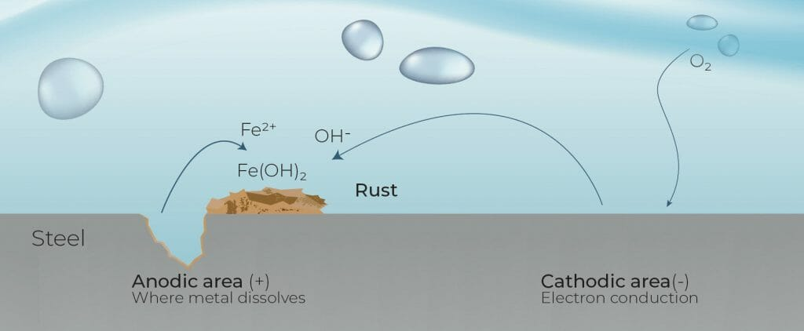
The alternative additives contain lead that is poisonous, and affects the environment in different ways. Manganese is also another additive that is a component of the released vehicle fumes. It might not be in big amounts, but it has an impact on environmental health. The combustion process of lead may begin at the pre-ignition point (Wang et al., 2015). This is where another spark front apart from the main spark is introduced before the start of the news cycle. This causes pre-mature combustion, and a lot of waste is produced as the carbon is not completely. This can be prevented by the addition of halo alkanes in order to get rid of the PbO that has accumulated, hence avoiding the spark.
RECOMMENDATIONS
During the installation of the exhaust catalytic reactors, the role of these reactors is to convert the harmful products produced as pollutants into less harmful waste before realizing them into the atmosphere. The cost of installation cannot be compared to the environmental value created by avoiding pollution. The cost of the consequences of these pollutions are greater and spread to even those who never participated in the pollution. The engine design can be improved mainly through the carburetor and combustion chamber to allow efficient emission without much waste.

Reference
Wang, Z., Liu, H., Song, T., Qi, Y., He, X., Shuai, S., & Wang, J. (2015). Relationship between super-knock and pre-ignition. International Journal of Engine Research, 16(2), 166-180.
Rubin, S., Parr, T., Da Costa, L., & Friston, K. (2020). Future climates: Markov blankets and active inference in the biosphere. Journal of the Royal Society Interface, 17(172), 20200503.

